**DAY 4**

1. List all customers and the products they ordered with the order date. (Inner join)

**Tables used:** customers, orders, order_details, products

**Output should have below columns:**

companyname AS customer,

orderid,

productname,

quantity,

orderdate

**Ans**:

**Query**:

**select c.company_name AS customer,**

**o.order_id, o.order_date,**

**od.quantity,**

**p.product_name**

**from customers c**

**inner join orders o on c.customer_id = o.customer_id**

**inner join order_details od on o.order_id = od.order_id**

**inner join products p on od.product_id = p.product_id;**

Output:

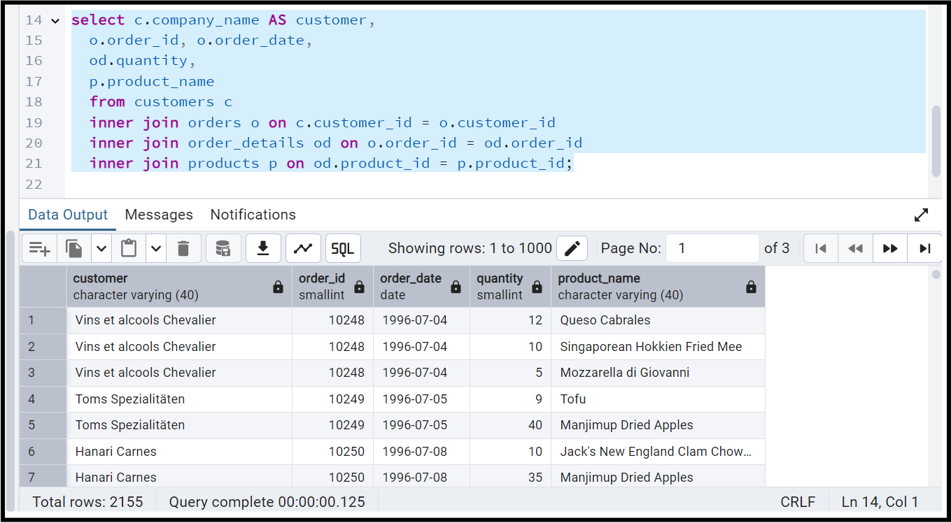

2. Show each order with customer, employee, shipper, and product info — even if some parts are missing. (Left Join)

**Tables used: orders, customers, employees, shippers, order_details, products**

**Query:**

select o.order_id, o.order_date,

o.required_date,o.ship_via,o.freight,

c.company_name AS customer,

e.first_name ||' '||e.last_name as emp_fullname, e.title,

od.quantity,

p.product_name

from orders o

left join customers c on o.customer_id = c.customer_id

left join order_details od on o.order_id = od.order_id

left join products p on od.product_id = p.product_id

left join employees e on o.employee_id = e.employee_id;

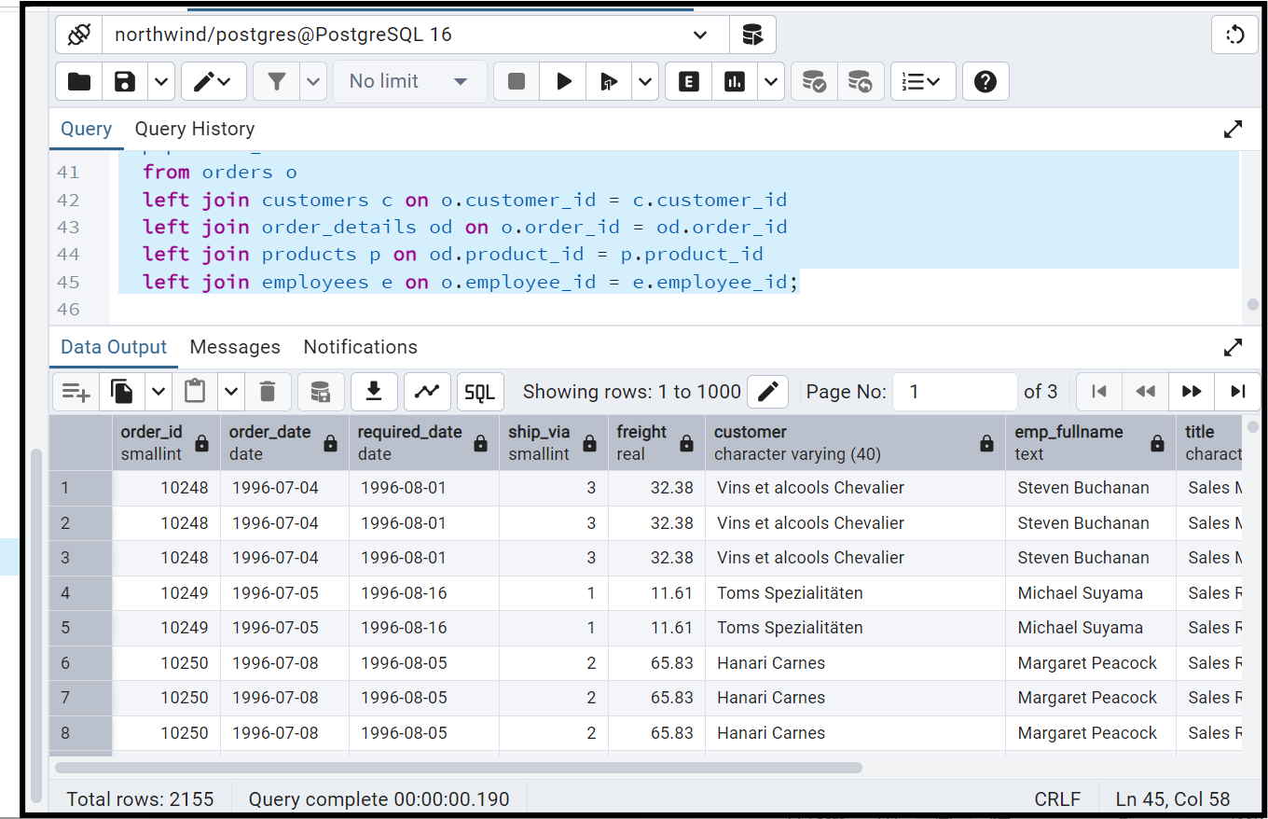

3. Show all order details and products (include all products even if they were never ordered). (Right Join)

**Tables used: order_details, products**

**Output should have below columns:**

orderid,

productid,

quantity,

productname

**Query:**

select od.order_id,od.product_id,

od.quantity, p.product_name

from order_details od

right join products p

on od.product_id = p.product_id;

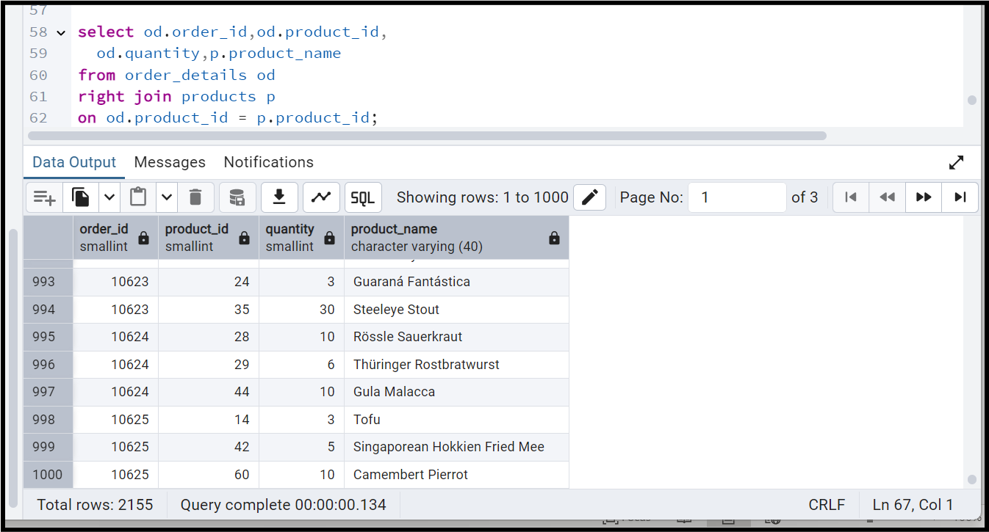

4. List all product categories and their products — including categories that have no products, and products that are not assigned to any category.(Outer Join)

**Tables used: categories, products**

**Query:**

**select * from categories cat**

**full outer join products p**

**on cat.category_id = p.category_id;**

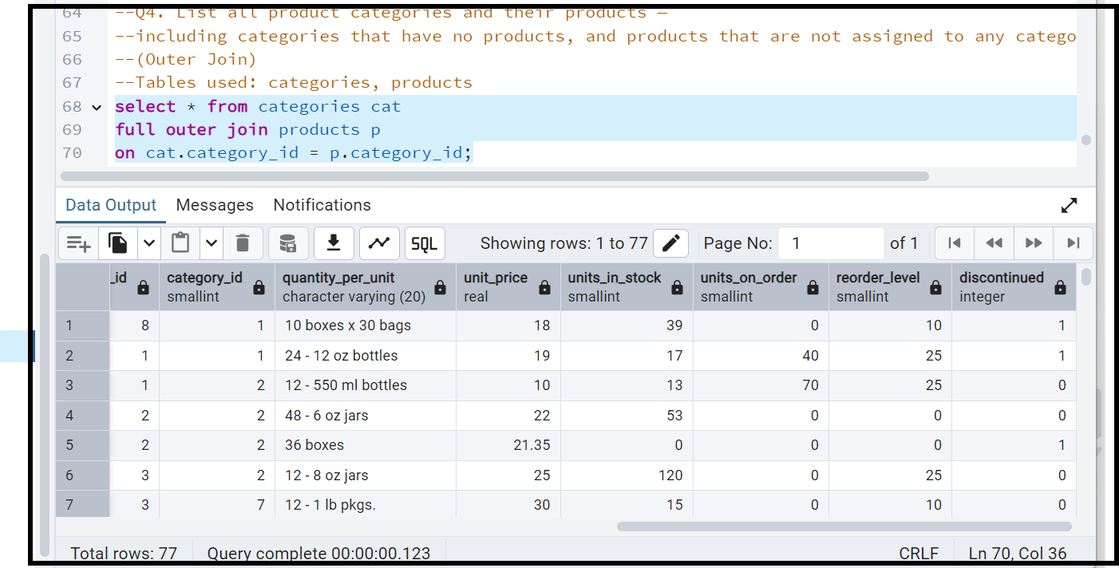

5. Show all possible product and category combinations (Cross join).

**Query**:

select * from categories

cross join products;

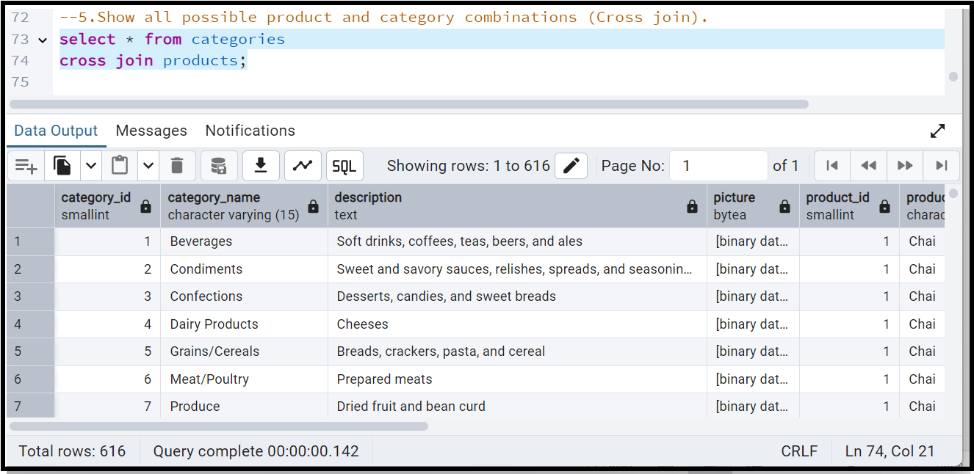

6. Show all employees and their manager(Self join(left join))

**Query:**

select e.first_name || ' '||e.last_name as employee_name,

COALESCE(m.first_name || ' ' || m.last_name, 'No Manager') AS manager_name,

e.employee_id,e.reports_to

from employees e

left join employees m

on e.employee_id = m.reports_to;

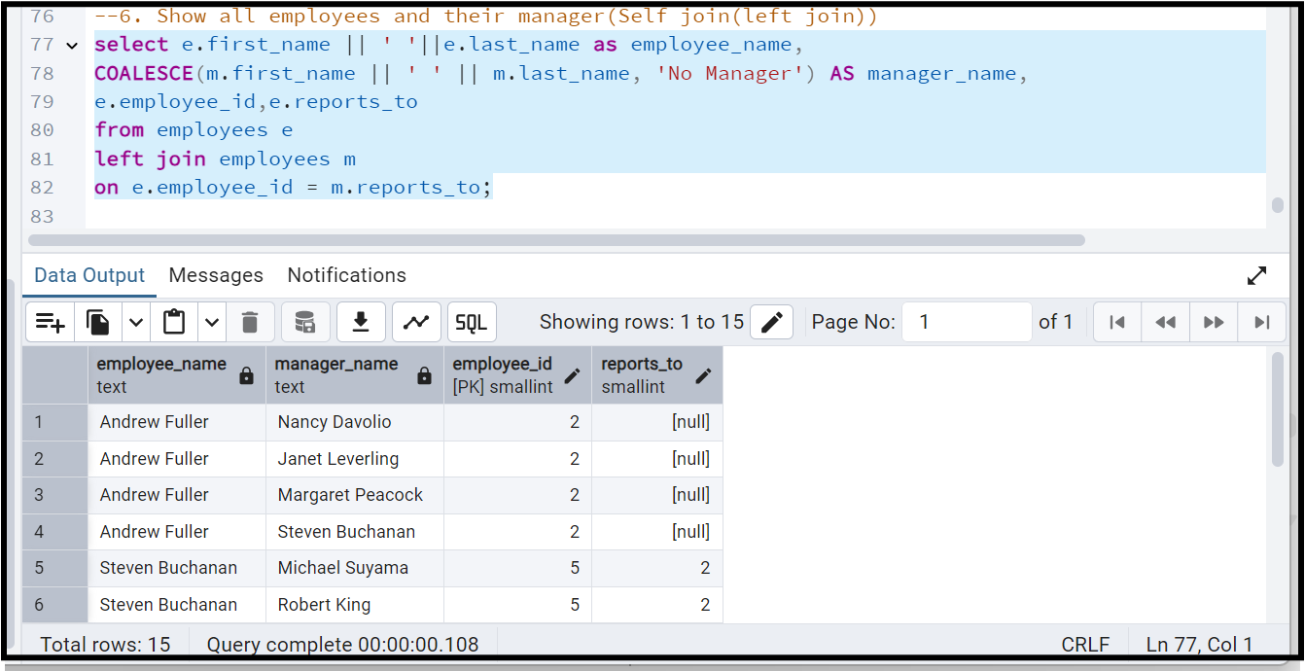

7. List all customers who have not selected a shipping method.

**Tables used:** customers, orders

**(Left Join, WHERE o.shipvia IS NULL)**

**Query**:

select

c.*,o.ship_via

from customers c

left join orders o on c.customer_id = o.customer_id

WHERE o.ship_via IS NULL;

